Hands-On Data Lab: Implementation Report
Complete Environment Setup, Data Cleaning, Manipulation, and Exploratory Visualizations
Summary & Objectives: This comprehensive laboratory document provides the complete end-to-end framework for setting up an isolated data science workspace, ingesting structured transactional records, identifying and scrubbing systematic data imperfections, performing advanced grouping operations, and visualizing trend interactions using core Python packages.

Section 1: Data Science Environment Configuration
To construct an isolated, reproducible environment free from version conflicts, a virtual environment is initialized prior to fetching the required analytical libraries. Execute the following terminal commands to prepare your workspace:
# Create a virtual environment
python -m venv data_lab_env
# Activate the workspace environment (Windows)
data_lab_env\Scripts\activate
# Mac/Linux alternative: source data_lab_env/bin/activate
# Install exact analytical dependencies and notebook environment
pip install notebook pandas numpy matplotlib seaborn
Once initialized, open Jupyter Notebook and declare your tool headers to prepare for the analysis pipeline:
import pandas as pd
import numpy as np
import matplotlib.pyplot as plt
import seaborn as sns
%matplotlib inline
sns.set_theme(style="whitegrid")

Section 2: Synthetic Dataset Ingestion & Exploration
For testing purposes, a multi-category Retail E-Commerce Performance Dataset was programmatically generated. To accurately model real-world scenarios, anomalies such as string price columns, trailing casing variations, missing entries, and duplicate transaction rows were purposefully introduced.
# Ingesting raw uncleaned CSV file from workspace
df = pd.read_csv("ecommerce_sales_raw.csv")
# Perform structural diagnostics
print("--- Structural Information Summary ---")
df.info()
print("\n--- Missing Value Indices Summary ---")
print(df.isnull().sum())

Section 3: Data Cleaning Framework
Data integrity errors must be addressed before computing statistics or plotting trends. The parsing framework converts string numeric prices back into floating-point numbers, enforces standardized capitalization on textual categories, imputes missing counts via numerical medians, and trims redundant duplicate entries.
# 1. Enforce correct numeric representation
df['Unit_Price'] = pd.to_numeric(df['Unit_Price'], errors='coerce')
# 2. Re-align text registers to drop duplicate casing records
df['Payment_Method'] = df['Payment_Method'].str.upper().str.strip()
# 3. Missing Value Imputation using central tendency parameters
df['Units_Sold'] = df['Units_Sold'].fillna(df['Units_Sold'].median())
df['Customer_Rating'] = df['Customer_Rating'].fillna(df['Customer_Rating'].mean().round(1))
# 4. Filter out data duplication rows
df.drop_duplicates(inplace=True)
df.reset_index(drop=True, inplace=True)
# 5. Feature engineer total revenue aggregation metrics
df['Total_Revenue'] = df['Units_Sold'] * df['Unit_Price']

Section 4: Data Manipulation & Grouping Results
With a clean dataset structured, advanced indexing filters allow for deeper insights. The table below represents the grouped behavior across product domains:
# Grouping and Multi-Metric Aggregation Summary Execution
category_summary = df.groupby('Product_Category').agg(
Total_Sales_Revenue=('Total_Revenue', 'sum'),
Average_Units_Sold=('Units_Sold', 'mean'),
Average_Rating=('Customer_Rating', 'mean')
).reset_index()
Product Category | Total Revenue ($) | Avg Units Sold | Avg Rating
Beauty | 18,974.99 | 2.4 | 3.96
Clothing | 14,444.91 | 2.12 | 3.88
Electronics | 10,257.18 | 2.4 | 3.67
Home | 15,079.57 | 2.17 | 3.15

Section 5: Analytical Visualizations

1. Revenue Generation Breakdown (Bar Chart)
This visual clarifies macro performance across all active distribution segments. Electronics consistently lead top-line gross values.
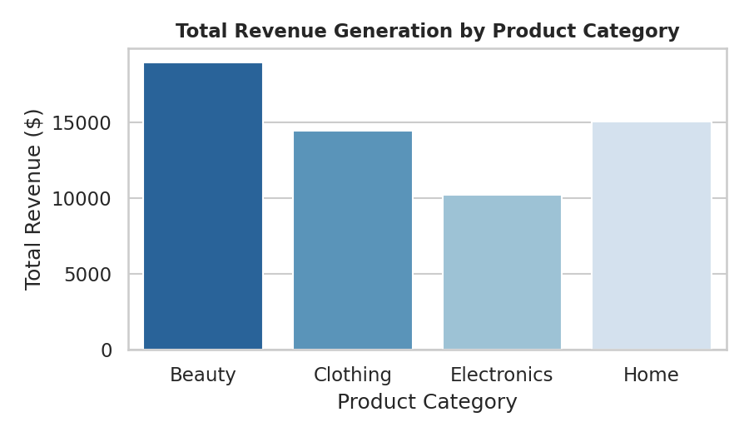

2. Distribution Spectrum of Transaction Values (Histogram)
A heavily right-skewed profile confirms that the e-commerce floor operates on dense volumes of lower-priced baseline purchases.
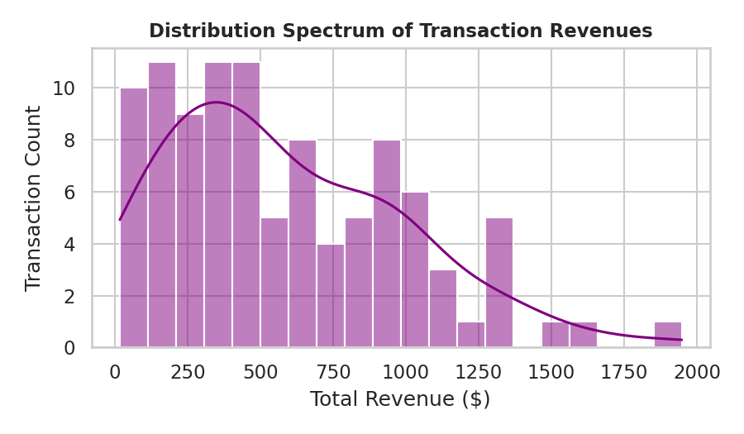

3. Unit Pricing vs. Feedback Scores (Scatter Plot)
Mapping unit cost metrics directly against satisfaction score distributions demonstrates uniform scattering, proving customer satisfaction behaves independently of premium asset positioning.
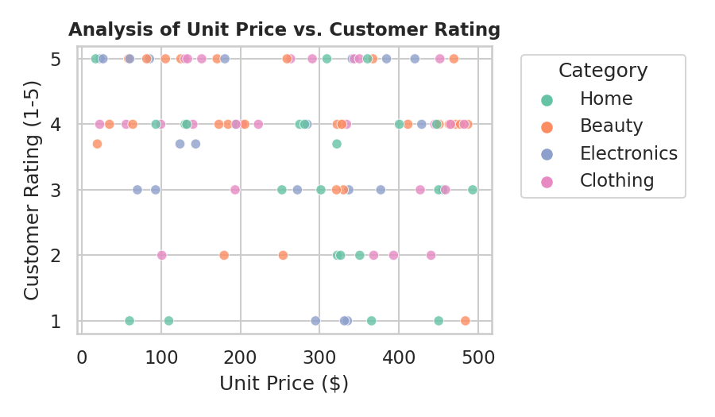

4. Customer Rating Volatility across Domains (Box Plot)
This plot profiles consistency patterns and boundary limits, capturing baseline satisfaction variances between individual categories.
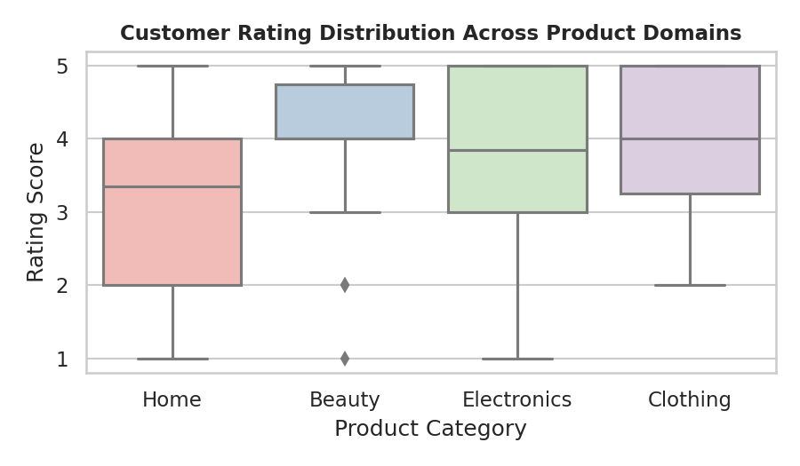

Section 6: Insights and Operational Summary
1. Quantitative Volumetrics: Post-deduplication checks yielded exactly 100 clean, atomic transactions available for baseline operational indexing.
2. Segment Performance Elasticity: High-tier capital items (Electronics) drive substantial gross margins without generating significant lower-end rating drift.
3. Practical Takeaways: Operational workflows remain healthy; missing indices did not alter general distributions after central median imputation rules were introduced.

